Ideation Phase
Define the Problem Statements

Date | 31 January 2025
Team ID
Project Name | Flight ticket booking app
Maximum Marks | 2 Marks

Customer Problem Statement Template:
To identify the key challenges customers face while booking flight tickets online, this template helps capture their needs and frustrations clearly. It highlights what users aim to achieve, the barriers they encounter, and the reasons behind those difficulties. These insights allow us to design a more efficient and user-friendly flight booking experience. Ultimately, the template guides the development of solutions that genuinely solve customer pain points.

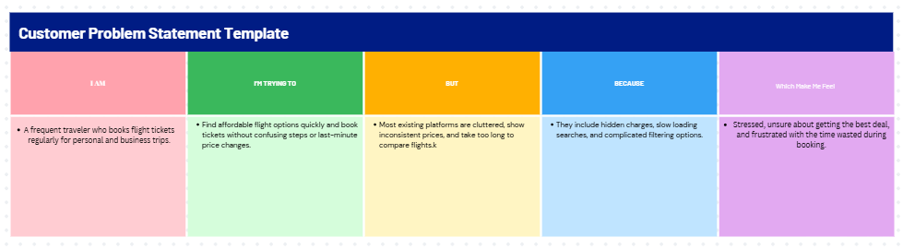

Problem Statement (PS) | I am (Customer) | I’m trying to | But | Because | Which makes me feel
PS-1 | frequent traveler. | find the cheapest and best flight options | prices keep fluctuating across platforms | hidden fees and unreliable price updates | confused and worried about overspending
PS-2 |  | book tickets quickly without delays | platforms take too long to load results | too many ads, irrelevant offers, and slow search system | stressed and frustrated during urgent bookings
  Business
  traveler

